Chip back potential is the level which bulk silicon is maintained by on-chip connection, or it is the level to which the chip back must be connected when specifically stated below. If no potential is given the chip back should be isolated.

.028”

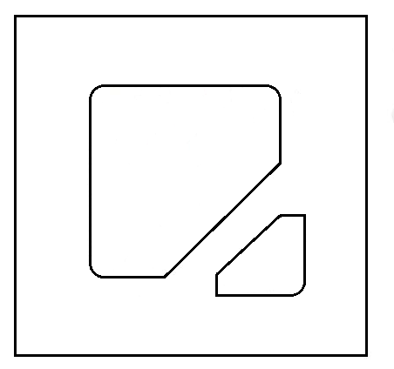
C
.023”
.023”
.008”
A

.028”

FOR ZENER OPERATION:
CATHODE MUST BE OPERATED POSITIVE WITH RESPECT TO ANODE.

Top Material: Al
Backside Material: Au
Bond Pad Size: .008” min.
Backside: ISOLATED

APPROVED BY: DK DIE SIZE .038” X .038” DATE: 10/21/21
MFG: MICROSEMI / CDI THICKNESS .010” P/N: 1N937A
DG 10.1.2

Rev B, 7/19/02

